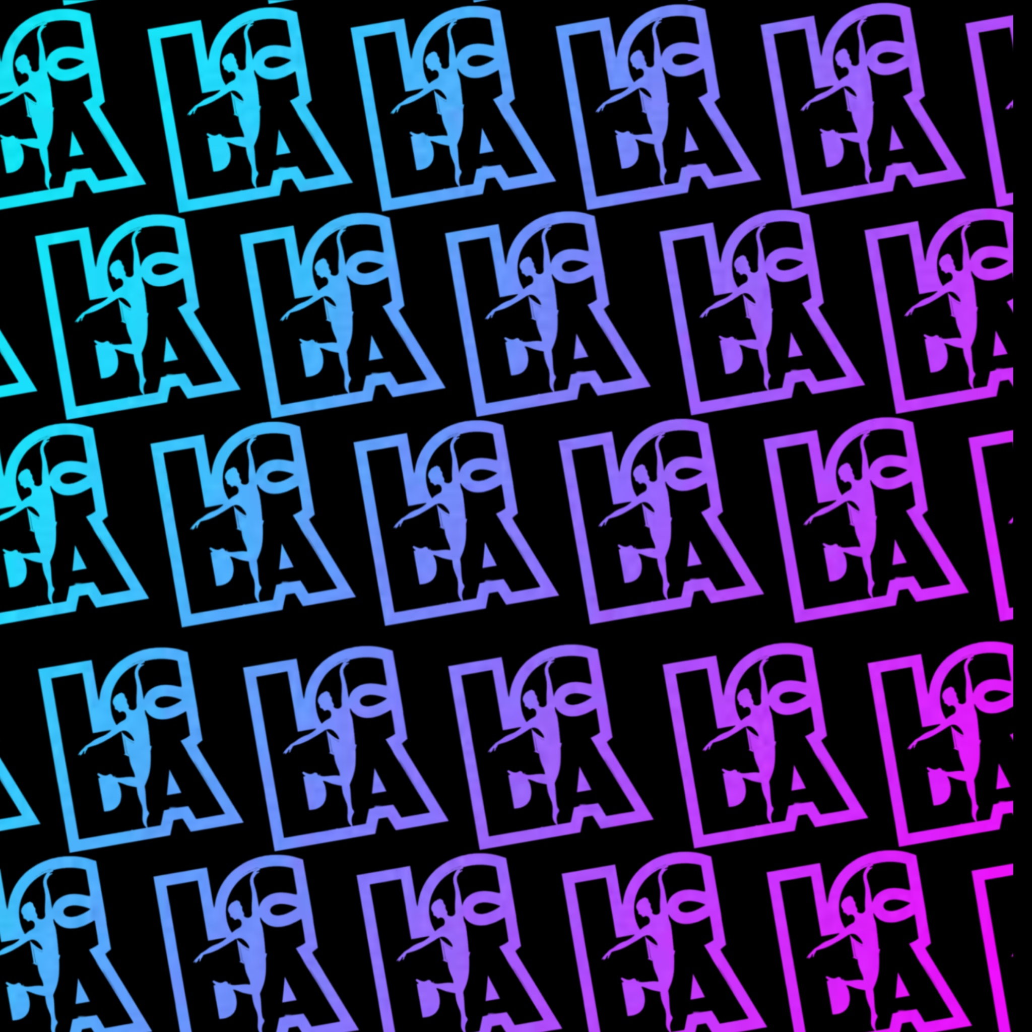
Kingaroy End Of Year Concert - Running Order

Item # | Dance Name | Class
1 | Opening | All Cast in 1st half
2 | The Wizard | Junior Jazz
3 | One Short day | Beginner Tap
4 | Me too | La Crème Kids
5 | Popular | Junior Acro
6 | Fabulous Elphaba & Glinda | Beginner Jazz
7 | Somewhere Over the Rainbow | Advanced/Senior Ballet
8 | The Wizard and I | Junior Ballet
9 | Born This Way | Beginner Aerial
10 | Defying Gravity | Junior Aerial
11 | I’m Not That Girl | Beginner Ballet
12 | What is This Feeling | Junior Tap
13 | Its Magic | Beginner Acro
14 | Finale | All Cast in 1st half
INTERVAL
1 | Break Ya Neck | Advanced Hip Hop
2 | Blackout | Intermediate Jazz
3 | Groove is in the Heart | Advanced/Senior Acro
4 | Cooler Than Me | Intermediate Tap
5 | Abracadabra | Senior Tap
6 | Angels by the Wing | Intermediate Aerial
7 | Ordinary | Advanced Aerial
8 | Ashes | Senior Aerial
9 | Shaboozy | Intermediate Ballet
10 | Boom | Advanced Tap
11 | Nails | Senior Hip Hop
12 | Human | Intermediate Acro
13 | Mr Worldwide | Senior Heels
14 | Home | Advanced Contemporary
15 | Strong | Intermediate Contemporary
16 | Mansion | Senior Contemporary
17 | Chicago | Advanced Heels
18 | Blah Blah Blah | Intermediate Hip Hop
19 | Vogue | Senior Jazz
20 | Pon de Replay | Advanced Jazz
21 | Finale | All Cast in 2nd Half

